 CANDIDATE DECLARATION FORM

Note: Please fill complete and correct information in the below
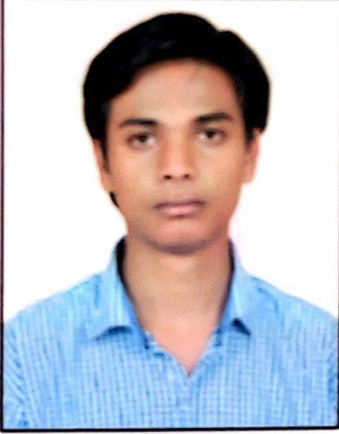

Photo
table.

Please fill this form in Capital letters and do not use
abbreviations.

Attach all the necessary education and employment
Documents.

PERSONAL INFORMATION
Full Name | HIMANSHU SAHU
Contact no | 8130516737 | Email ID | HIMANSH.DIT@GMAIL.COM
Father’s Name | MR. NARAYAN PRASAD SAHU | Gender | Male Female  Other
Actual D.O.B  (DD/MM/YYYY) | 27/12/1996 | Certificate D.O.B  (DD/MM/YYYY) | 27/12/1996
Current  Address | Q-1102, CONCORDE MANHATTAN APARTMENTS  BANGALORE  PIN 560100 | Permanent Address | W.NO. 10, JAIRAMNAGAR, MASTURI,  BILASPUR, PIN 495550,  CHHATTISGARH
Landmark | ELECTONIC CITY PHASE-1 | Landmark | VILLAGE KHAIRA
Landline No. |  | Landline No.
Mobile | 8130516737 | Mobile | 8130516737
Period of Stay | 2.5 YEARS | Period of Stay | 10+ YEARS
Nature of Residence | RENTED HOUSE | Nature of Residence | PERMANENT HOUSE

Address & ID Proof:
(Please attach copy of the Address & ID proof)
PAN no | JKZPS2622J | Aadhar Card No. | 965157429861
Passport Details:  Name as per Passport:  Issue Date:  Expiry Date:  Place of Issue: | HIMANSHU SAHU  17/07/2018  16/07/2028  RAIPUR | Others:  (Driving License/ Voter ID  Details)

Academic Details

(Starting from most recent) (UG/PG/Diploma & Certification Courses)
(Please attach copy of the Academic Certificates with Mark sheets)
Particulars | Institution 1 | Institution 2 | Institution 3
Qualification | B.TECH(2nd YEAR ONWARDS) | B.TECH (1st YEAR)
Specialization | COMPUTER SCIENCE ENGINEERING | COMPUTER SCIENCE ENGINEERING
College Name | JAYPEE INSTITUE OF INFORMATION TECHNOLOGY | DIT UNIVERSITY
Address | A 10, A BLOCK, BLOCK A, INDUSTRIAL AREA, SECTOR 62, NOIDA, UTTAR PRADESH 201309 | MUSSOORIE, DIVERSION ROAD, MAKKA WALA, UTTRAKHAND 248009
University | JAYPEE UNIVERSITY OF INFORMATION TECHNOLOGY | DIT UNIVERSITY
Period  (From – To)  (dd/ mm/ yy) | 16/07/15 TO 31/01/18 | 10/07/15 TO 15/07/15
Program  (Part Time / Full Time) | FULL TIME | FULL TIME

S# | Referral Name | Referral's Designation/Role in the company you have worked | Contact Details |  | Company Name  (Name of the company that you and Referral worked together) | Candidate/  Employee's  (your) Designation/Role
S# | Referral Name | Referral's Designation/Role in the company you have worked | Phone no. | Email ID |  | Candidate/  Employee's  (your) Designation/Role
1 | SUDHARANI YARKREDDY | TECHNICAL MANAGER/MANAGER | 9632148497 | sudhayarkreddy@gmail.com | METRICSTREAM | MEMBER OF TECHNICAL STAFF – DEV
2 | ANSHUL TIWARI | ASSOCIATE PRINICIPAL ENGINEER/SENIOR TEAM LEAD | 8197930007 | anshul.ansul@gmail.com | METRICSTREAM | MEMBER OF TECHNICAL STAFF – DEV
3 | SRAVANI PATTI | MEMBER OF TECHNICAL STAFF/  TEAM MEMBER | 9440322200 | patthishravani@gmail.com | METRICSTREAM | MEMBER OF TECHNICAL STAFF – DEV
4
5
6

Note: Please share minimum 3 valid professional references (mobile no and email id mandatory).

Employment Details
(Please attach copy of Offer Letter, Appraisal/Promotion letter, Relieving letter/Experience Certificate/Service Certificate & 3 months Pay Slip/Salary Certificate)
Employment 1 (Latest)
Company Name | METRICSTREAM | Employee ID | MSI3526
Address | 23 & 24, 4th B, AMR TECH PARK INTERNAL ROAD, HONGASANDRA, BENGALURU, KARNATAKA 560068 | Period of Employment (DD/MM/YYYY) | 01/10/2018
City (postal code) | 560068 | Designation | MEMBER OF TECHNICAL STAFF - DEV
State | KARNATAKA | Remuneration | 6,50,000/-
Contact No. 1 | 9632148497 | Reported to | SUDHARANI YARKREDDY
Contact No. 2 |  | Reported Person Designation | TECHNICAL MANAGER
Reason for Leaving | LOOKING FOR GROWTH IN PYTHON DEVELOPMENT DOMAIN.
Employment 2
Company Name | INFOSYS | Employee ID | 12036587
Address | PLOT NO, 44, HOSUR ROAD, KONAPPANA AGRAHARA, ELECTRONIC CITY, BENGALURU, KARNATAKA 560100 | Period of Employment (DD/MM/YYYY) | 05/02/2018
City (postal code) | 560100 | Designation | SYSTEM ENGINEER
State | KARNATAKA | Remuneration | INR 27,084 per month
Contact No. 1 |  | Reported to
Contact No. 2 |  | Reported Person Designation
Reason for Leaving | PROJECT UNASSIGNED, ON BENCH FOR LONGER DURATION.
Employment 3
Company Name |  | Employee ID
Address |  | Period of Employment (DD/MM/YYYY)
City (postal code) |  | Designation
State |  | Remuneration
Contact No. 1 |  | Reported to
Contact No. 2 |  | Reported Person Designation
Reason for Leaving
Employment 4
Company Name |  | Employee ID
Address |  | Period of Employment (DD/MM/YYYY)
City (postal code) |  | Designation
State |  | Remuneration
Contact No. 1 |  | Reported to
Contact No. 2 |  | Reported Person Designation
Reason for Leaving
Employment 5
Company Name |  | Employee ID
Address |  | Period of Employment (DD/MM/YYYY)
City (postal code) |  | Designation
State |  | Remuneration
Contact No. 1 |  | Reported to
Contact No. 2 |  | Reported Person Designation
Reason for Leaving
Employment 6
Company Name |  | Employee ID
Address |  | Period of Employment (DD/MM/YYYY)
City (postal code) |  | Designation
State |  | Remuneration
Contact No. 1 |  | Reported to
Contact No. 2 |  | Reported Person Designation
Reason for Leaving

Other Details
If yes, please elaborate.
1.) Are you currently under service agreement / bond with any other employer? (Yes / No) | YES  Notice Period Serving
2.) Have you ever been charged or convicted in any court in India or abroad? (Yes / No) | NO
3.) Do you know or are related to anyone who works for the company?  (Yes / No) | NO

Onsite Details
(Please attach copy of the Visa filling pages in Passport)
Name of the Country | Visa Type | Duration of Stay | Purpose

LETTER OF AUTHORIZATION:

I hereby authorize all who may have information relevant to this enquiry to disclose it to Accion Labs India Private Limited and / its representative. I release all concerned from any liability on account of such disclosures.

I also declare that the information provided by me in my resume/ application and interview for employment to Accion Labs India Private Limited and / its representative is authentic and I am liable for all inaccuracies and omissions.

I promise to extend total co-operation and provide relevant documents required.

Full name : HIMANSHU SAHU

Date : 26-APR-2021

Place : BANGALORE

Signature : HIMANSHU SAHU

